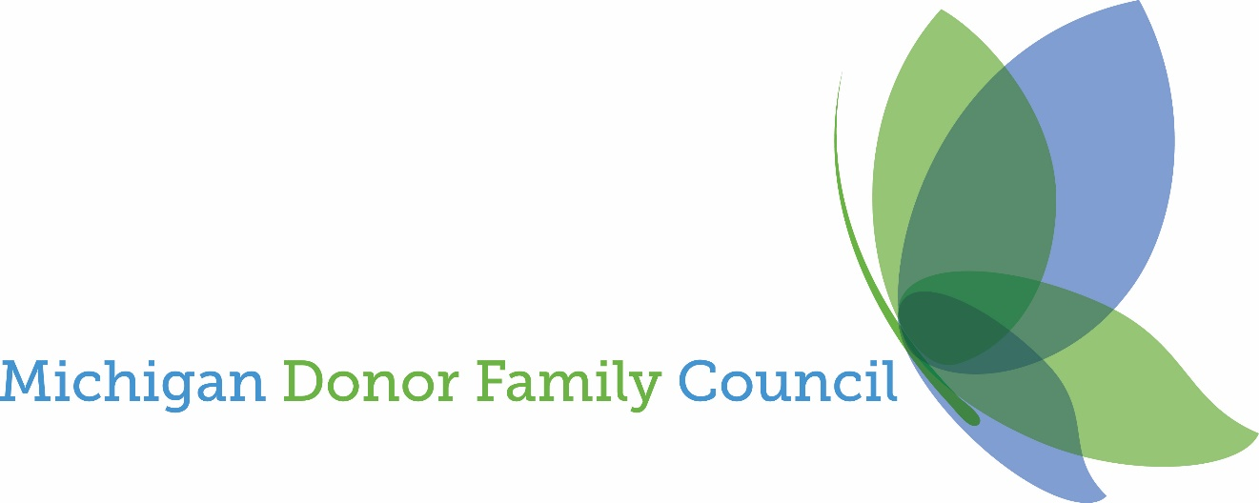

2022 Travel Grant Application
Donate Life Transplant Games of America

What is a Michigan Donor Family Council (MDFC) Travel Grant?
The grant offers people seeking assistance with travel costs to the Transplant Games of America in San Diego, California, July 29 - August 3, 2022.

The number of Travel Grants and Amounts:
One Grant for $2,000.00

Who can apply?
Applicants must be donor family members (tissue, eye, or organ) or living donors.
- MDFC members or their extended family members are not eligible.
- A family offered a travel grant through Team MI is not eligible.

Application:
Applicants complete a one-page document explaining why donation is important to you.

Reimbursement Policy:
The grant is a reimbursement policy. The family must submit receipts for all eligible expenses within two weeks of returning from the Games.

Grant Award Timeline:
Applications will be accepted by April 15, 2022.

Please complete the application by April 15, 2022
Submit to Patty Jo Herndon
pjherndon@herndon-assoc.com

The winner will be announced the week of April 22, 2022

Applicant Information:

Name (First, Last): ______________________________

Address: ______________________________________

City, State, Zip: _________________________________

Cell Phone: ____________________________________

Other Phone: ___________________________________

Email address: __________________________________

Applicant Type:

Living donor _____________________________

Donor family member _____________________

Please submit a one-page document explaining why donation is important to you.

